**Appendix 11**. Full model results for the intra-city urbanization gradient analysis, for four biodiversity variables (i.e., species richness, Shannon diversity, abundance, and phylogenetic diversity). Model results are presented both for (1) analyses which only investigated the relationship between a smoothed urbanization level; and (2) parametric models where urbanness was included as a parametric term, as well as other macro-ecological predictors.

**Table A1**. Model results from a GAM, showing the relationship between species richness at a checklist level with a continuous measure of urbanization (VIIRS night-time lights).

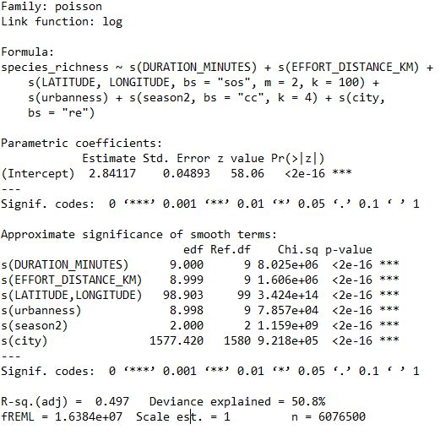

**Table A2**. Model results from a GAM, showing the relationship between Shannon diversity at a checklist level with a continuous measure of urbanization (VIIRS night-time lights).

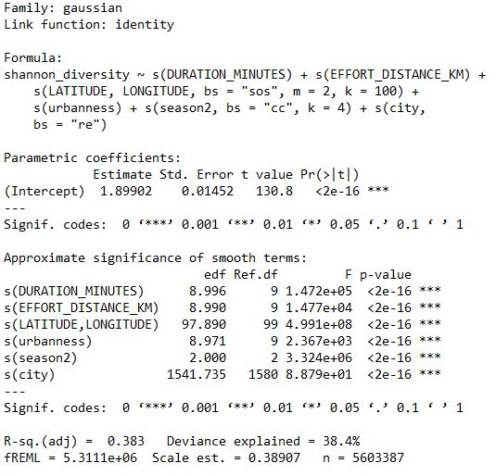

**Table A3**. Model results from a GAM, showing the relationship between total abundance of individuals at a checklist level with a continuous measure of urbanization (VIIRS night-time lights).

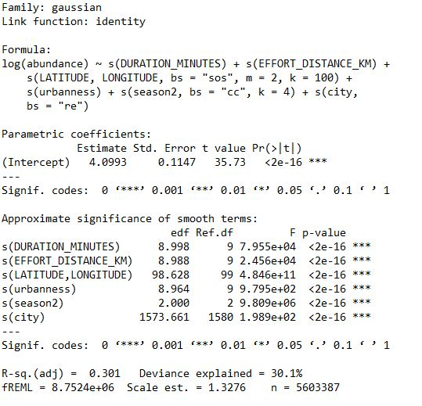

**Table A4**. Model results from a GAM, showing the relationship between phylogenetic diversity at a checklist level with a continuous measure of urbanization (VIIRS night-time lights).

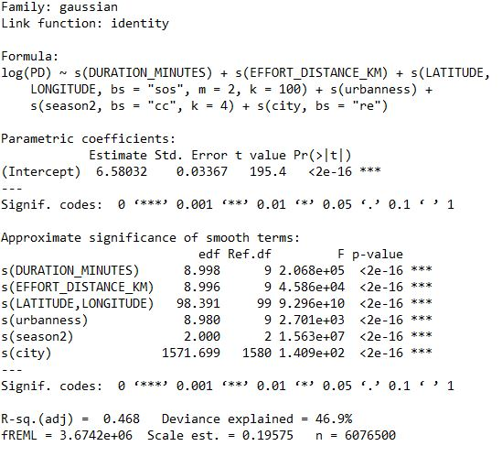

**Table A5**. Model results from a GAM, showing the relationship between species richness at a checklist level with macro-ecological parametric predictors, including urbanization (VIIRS night-time lights).

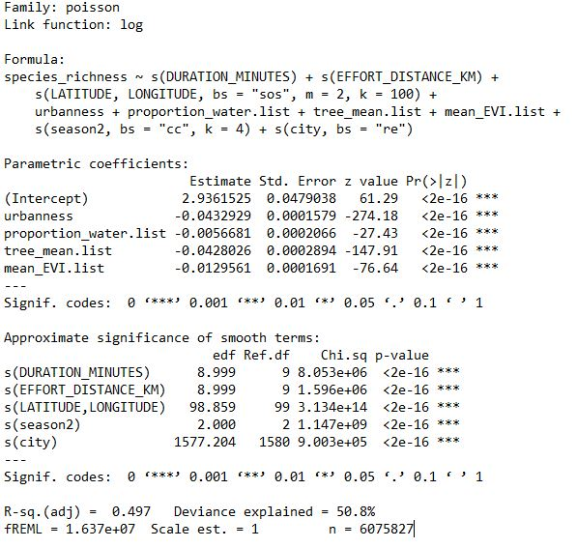

**Table A6**. Model results from a GAM, showing the relationship between Shannon diversity at a checklist level with macro-ecological parametric predictors, including urbanization (VIIRS night-time lights).

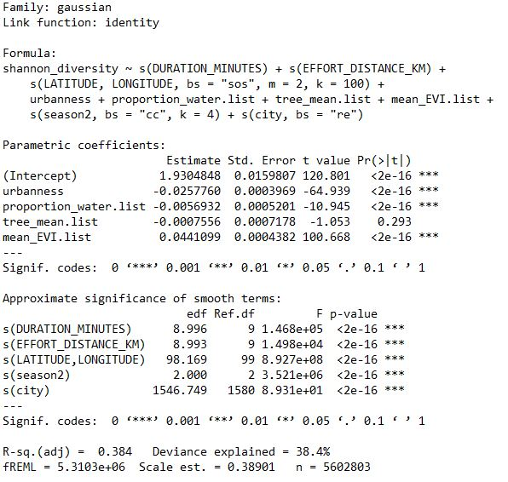

**Table A7**. Model results from a GAM, showing the relationship between total abundance of individuals at a checklist level with macro-ecological parametric predictors, including urbanization (VIIRS night-time lights).

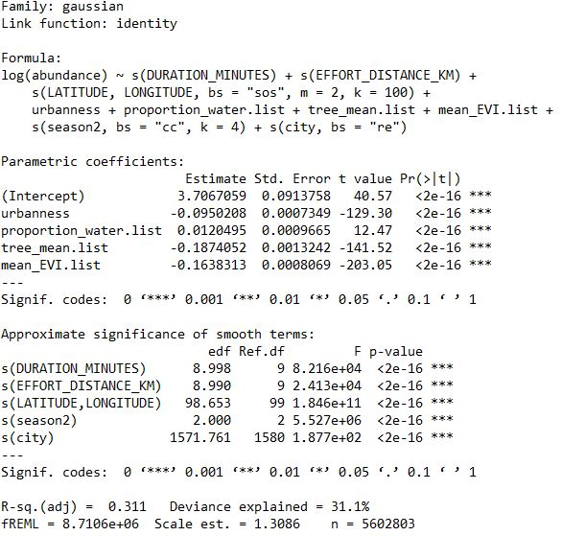

**Table A8**. Model results from a GAM, showing the relationship between phylogenetic diversity at a checklist level with macro-ecological parametric predictors, including urbanization (VIIRS night-time lights).

